B.Ed + MA Together: How Girls Can Save Two Years and Build a Stronger Teaching Career
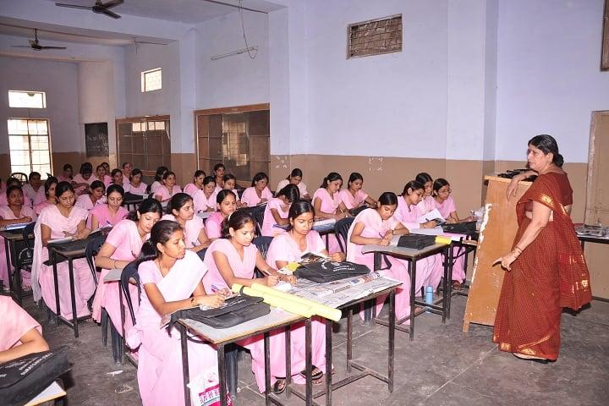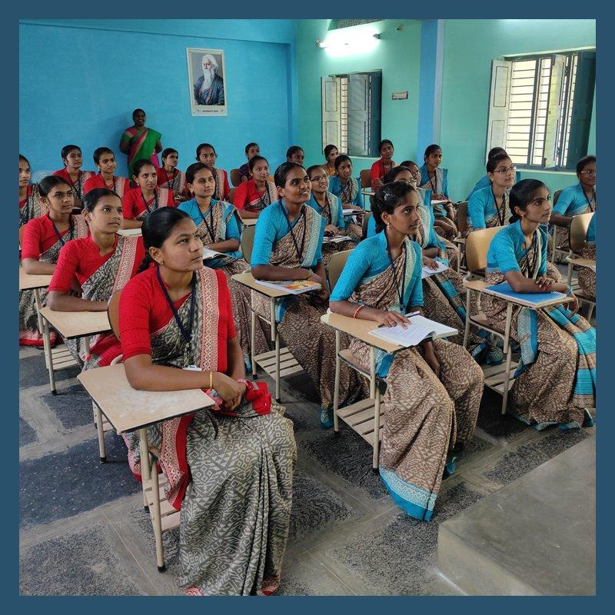
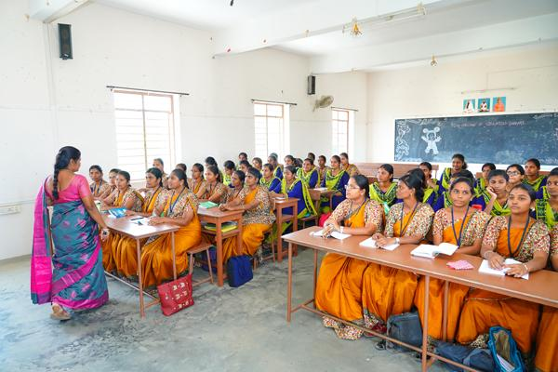
SEO Title
B.Ed + MA Together: How Girls Can Save Two Years & Prepare for PGT Teaching Jobs
Primary Keyword
B.Ed + MA together
Secondary Keywords
- B.Ed and MA together
- B.Ed + MA integrated course
- B.Ed MA together in Delhi
- B.Ed MA admission 2026
- PGT qualification
- PGT teacher eligibility
- MA and B.Ed together
- Best B.Ed institute in Paschim Vihar
- B.Ed admission 2026 Delhi
- MA admission 2026 Delhi
- teaching career after graduation
- PGT teacher qualification

B.Ed + MA Together: How Girls Can Save Two Years and Build a Stronger Teaching Career
For many girls, education is not simply about earning a degree. It is about building financial independence, professional confidence and a stable career.
But there is one major challenge: time.
A student who completes an MA and B.Ed one after another may spend several additional years completing the qualifications needed for a teaching career. This is why the concept of pursuing B.Ed + MA together, wherever permitted by the concerned universities and applicable regulations, can be an attractive academic pathway for eligible students.
For girls who want to enter the teaching profession, planning these qualifications together can potentially help them save time and enter the job market earlier.

Why Are MA + B.Ed Important for Teaching?
Teaching requirements vary according to the school, subject, post, state and recruitment authority.
However, NCTE's published qualification framework specifies that for Senior Secondary/Intermediate teaching, the qualification includes a Master's degree in the relevant subject along with B.Ed. or an equivalent qualification, subject to the applicable recruitment rules.
This is particularly relevant for students targeting PGT-level teaching opportunities.
Therefore, a graduate who is serious about becoming a senior-school teacher should think beyond simply completing graduation.
The bigger question is:
What qualifications will I need for the teaching position I ultimately want?

Why Should Girls Consider B.Ed + MA Together?
1. Save Valuable Time
Time is extremely important, especially for students who want to establish their career early.
If the two qualifications can be pursued concurrently through programmes that legally and academically permit simultaneous study, students may avoid unnecessarily extending their education timeline.
Instead of thinking:
Graduation → MA → B.Ed → Job
students can explore an appropriate pathway such as:
Graduation → MA + B.Ed → Teaching Career
The actual duration and simultaneous-study rules must always be confirmed with the respective university/program.

2. Prepare for PGT-Level Opportunities
For senior-secondary teaching, a relevant postgraduate qualification along with B.Ed is an important combination in many recruitment frameworks.
That makes MA + B.Ed a strategically useful combination for students who want to target PGT-level opportunities.
However, candidates should always check the latest recruitment notification because government and private-school eligibility requirements can differ.

3. More Career Options
An MA does not restrict a student to teaching alone.
Depending on the subject and qualifications, a postgraduate can explore:
- School teaching
- PGT-level opportunities
- Coaching and academic institutions
- Education content development
- Academic counselling
- Online teaching
- Educational administration
- Competitive examinations
- Further higher education
B.Ed adds a professional teacher-education qualification to the academic background.

Why This Can Be Especially Useful for Girls
Many girls want to establish their careers while also balancing family responsibilities.
A well-planned academic pathway can help reduce unnecessary gaps between qualifications.
Completing relevant qualifications earlier may mean:
Earlier eligibility → Earlier job applications → Earlier experience → Earlier financial independence
This does not mean education should be rushed.
It means education should be planned intelligently.

B.Ed + MA Admission 2026 at Aplomb India & We Teach
We Teach and Aplomb India in Paschim Vihar, West Delhi, provide education counselling for students planning their higher-education and teaching careers.
Students can discuss:
✔ B.Ed eligibility
✔ MA eligibility
✔ Suitable subject combinations
✔ University options
✔ Admission process
✔ Documentation
✔ Course duration
✔ Mode of study
✔ Future career pathways
The most important step is to verify that the specific B.Ed and MA programmes allow the proposed simultaneous study arrangement and that both qualifications will satisfy the eligibility requirements of the jobs you intend to apply for.

From Graduation to PGT: Plan Backwards
One of the best ways to plan a teaching career is to start with the desired job.
For example:
Target:
PGT Teacher
↓
Understand eligibility:
Relevant Master's + B.Ed. + other applicable requirements
↓
Choose the right MA subject
↓
Choose an appropriate B.Ed programme
↓
Complete both qualifications through permissible routes
↓
Prepare for recruitment examinations/interviews
↓
Build teaching experience
This approach prevents students from collecting degrees without knowing how those qualifications fit into their career plans.

Your Two Years Can Be More Valuable Than You Think
For a young woman beginning her professional journey, two years can represent much more than time on a calendar.
Two years can mean:
Two years of work experience.
Two years of professional growth.
Two years of financial independence.
Two years closer to your career goals.
That is why an intelligently planned B.Ed + MA pathway deserves consideration.

Start Your Teaching Career Planning with Aplomb India
Located in Paschim Vihar, West Delhi, Aplomb India is one of the well-known education institutes in the area, while We Teach focuses on higher-education guidance and programmes.
If your goal is to become a teacher, don't wait until after completing one degree to ask what qualification you need next.
Plan your academic journey today.
📞 Call Aplomb India / We Teach:
7503030309 | 8800600660
B.Ed + MA Admission 2026 – Start Planning Your Teaching Career Today.

Suggested website CTA
🎓 WANT TO BECOME A PGT TEACHER?
Get counselling for B.Ed + MA options for the 2026 admission session.
Call: 7503030309 | 8800600660
Visit Aplomb India, Paschim Vihar, West Delhi.

